Version Control

Samuel Cooke – s251388

Repository Link
Link: https://github.com/s251388/AIE-2.2.4-Pointers.git
Screenshot:
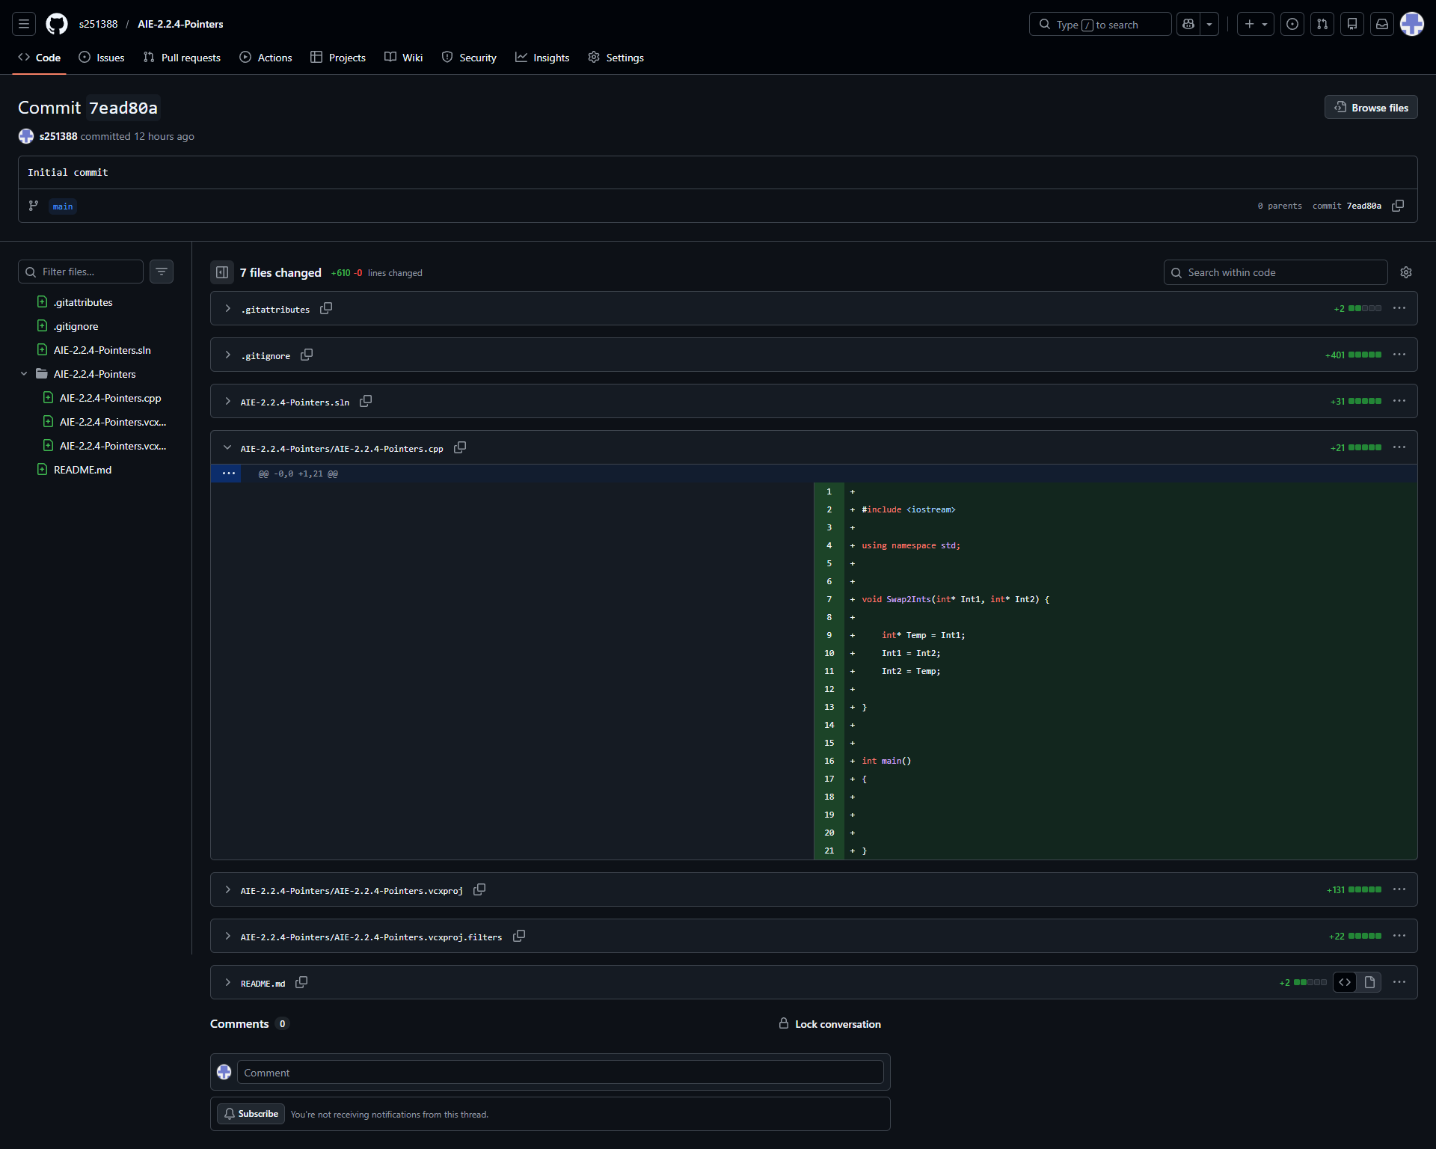
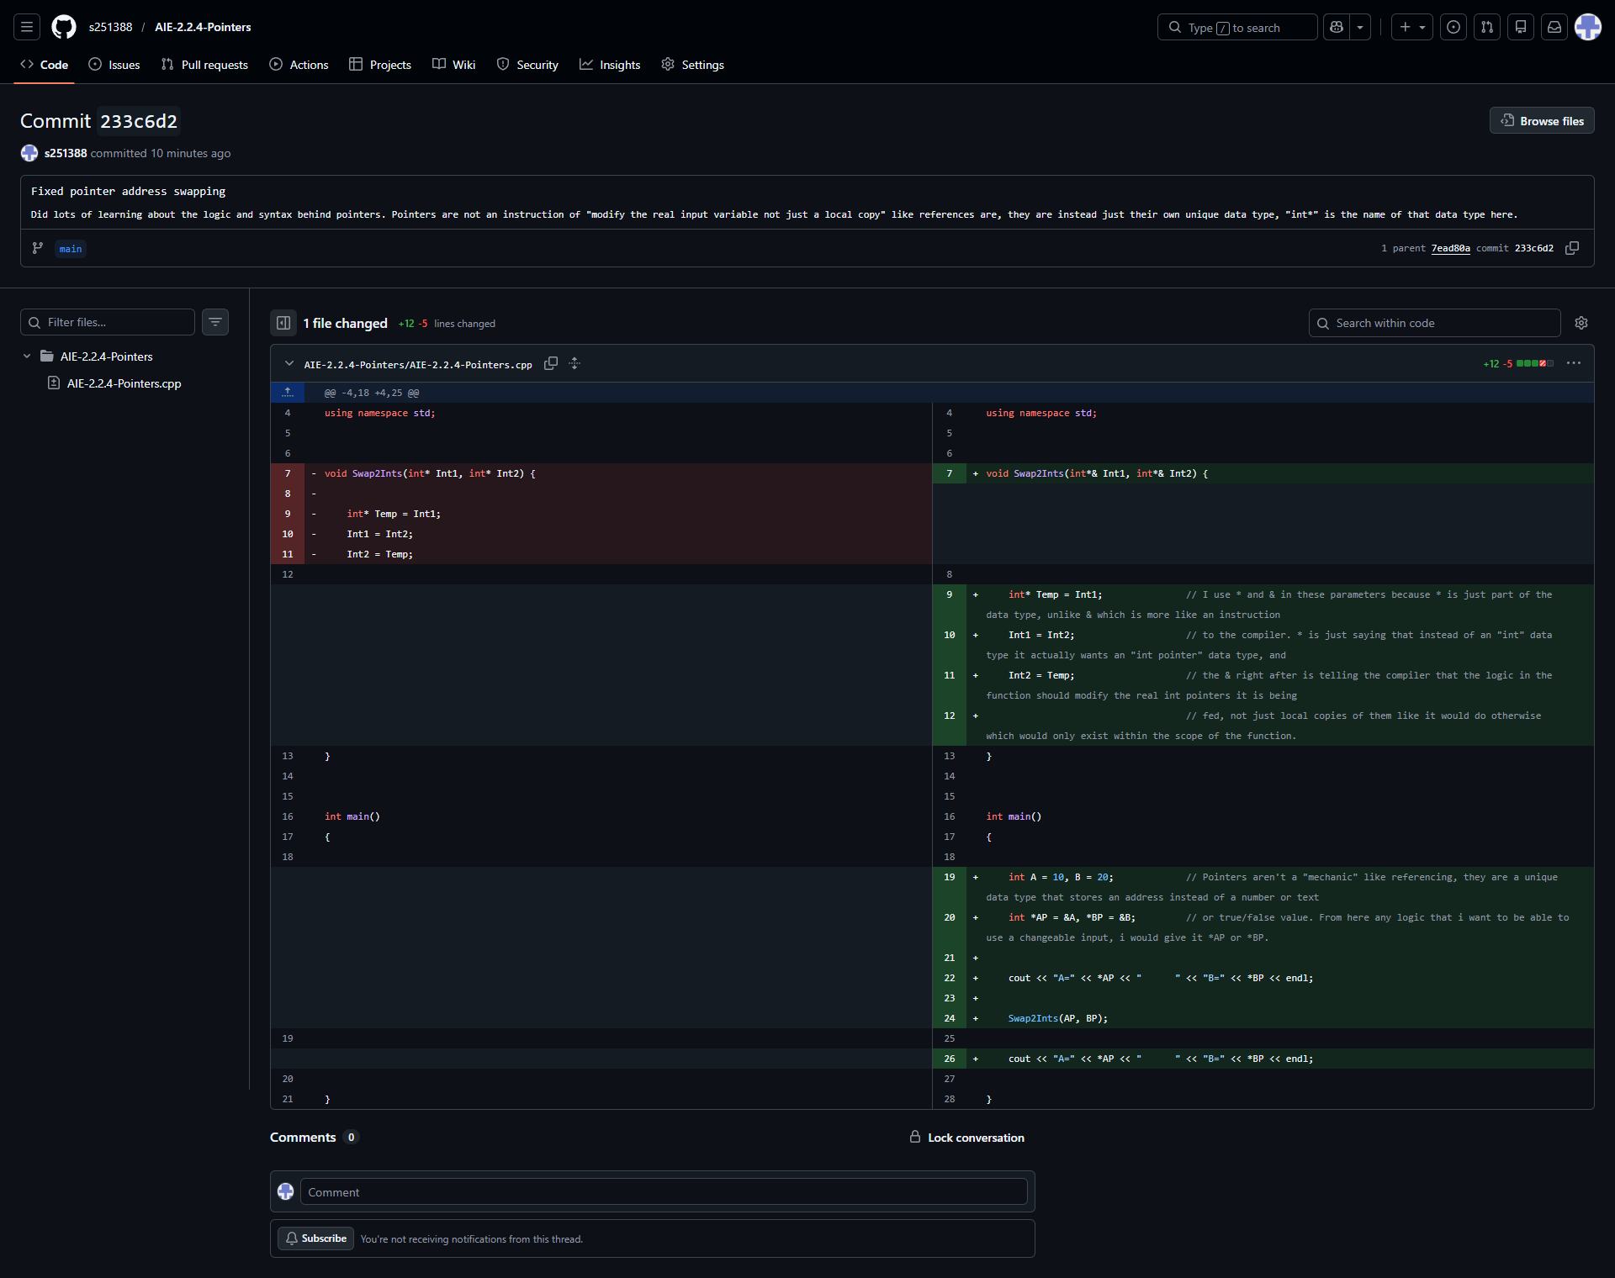
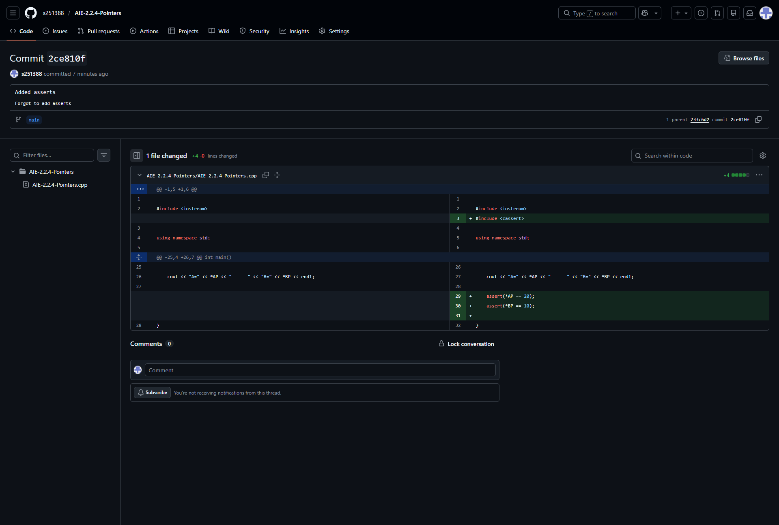

Resources:
- C++ Pointers: https://www.w3schools.com/cpp/cpp_pointers.asp
- Lots of random examples on Google Images

Challenges
Write a description of the challenges, mistakes made, or problems you personally encountered, and what you did to overcome, work around, or resolve these issues. (100 - 300 words).
I still hadn’t really messed with pointers up to this point, and in my head i was seeing them alot as just like references, and getting confused about how it should look to pass them into functions, but i’ve learned to better differentiate them by thinking about how references are like an instruction to the compiler, saying “Use the actual variable that is inserted here, not a local copy that would only exists within this scope”, and a pointer is just a data type (in this case int* is an int pointer data type) that holds an address to a desired variable for other logic to be able to access by dereferencing it. Dereferencing it is like referencing in that it’s more of an instruction, not a data type—“Get the information from wherever this address leads”.

Weaknesses
Write a list of personal weaknesses regarding version control and ways you could resolve these weaknesses. (100 - 300 words).
Still getting used to my own style.
Understanding syntax and concepts without the exact right example of it being explained to me.

